Iterative Ops in MR:

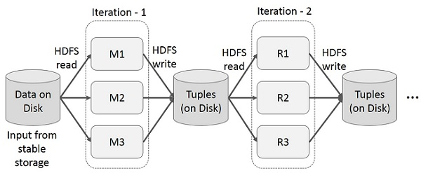

Interactive Ops in MR:

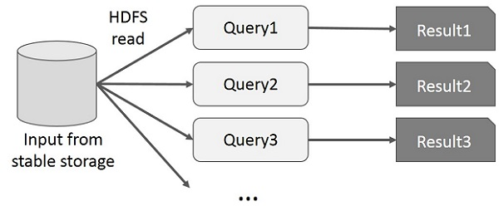

Iterative Ops in Spark RDD:

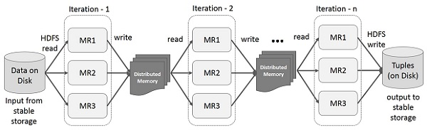

Interactive Ops in Spark RDD:

